Company: Unlimited

Date: 2/9/2020

Members: Kehan Meng, Linsong Li, Shixian Jing, Nicholas Boanca

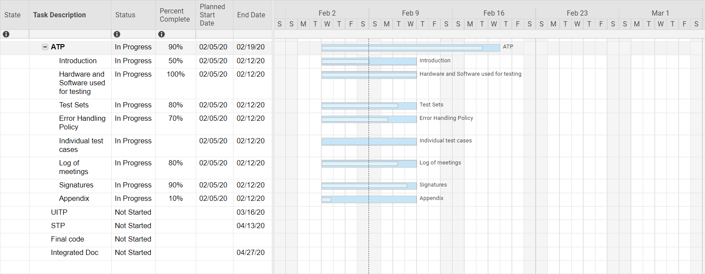

Work assignment:

Kehan Meng: Introduction and Error Handling Policy.

Linsong Li: Test Sets.

Shixian Jing: Hardware and Software used for testing, Log of meetings, signatures and appendix.

Nicholas Boanca: Individual test cases and organization.